Headteacher
Mr. N. B. Payling

North Yorkshire County Council

Cawood Church of England
Voluntary Aided Primary School
Broad Lane, Cawood, Selby, YO8 3SQ

Telephone 01757 268368
Email admin@cawood.n-yorks.sch.uk
Web www.cawoodprimary.ik.org

February 2018 Newsletter

Hope, Friendship, Thankfulness
Excellence and Enjoyment

At Cawood, everyone matters.

Dear parents and carers,

It is lovely to see the snowdrops appearing in gardens and at the roadside. They are small and quite beautiful flowers, sometimes, but not always, set against a backdrop of the dark cold earth, or the bareness left by the winter. The small delicate flowers are always a sign of hope and beauty, and it is always wonderful to see the white petals in the sunlight.
It has been a very busy few weeks at school with some great things happening. The children are enjoying the after school clubs and these will be changing after the holiday as we will be able to go outside more and use the playground. Look out for the netball and football clubs starting after half term and please complete the details later on in the newsletter.
This term was another first for me as I accompanied a small group to the leisure centre for climbing and bowling. The children were great ambassadors for the school and, whilst they did not compete against other schools, there was a lot of motivation and self-challenge which is wonderful to see in our children.
Sport and having an active lifestyle is so important to us all and particularly for children as they grow and develop. We are delighted to be working with Club Doncaster who lead the games lessons and provide some wonderful afterschool clubs. We are also competing in a number of local events. Unfortunately we missed the swimming event in January due to illness in school and other logistical difficulties that just made it impossible for us to take part.

Our next tournament is a tennis festival held at Brayton High School. This is for year 5 and 6 children and we have been invited to take 2 teams of 4 children. Usually everyone wants to join in but we can only select 8 children for this event and, as the year goes on, we try to give as many children the opportunity to join in with something. We are hoping to develop further links with the local tennis club and in April we are looking forward to the year 4 children going swimming. Please let us know if you can help with transport to any of our sporting events as it is difficult or costly to get the children there and back. Please complete the form at the end of the newsletter and send it in to us if you are able to help.

Climbing and bowling at the leisure centre in Selby.

Well done to the children who represented Cawood at this event. They were brilliant and a real credit to the school.

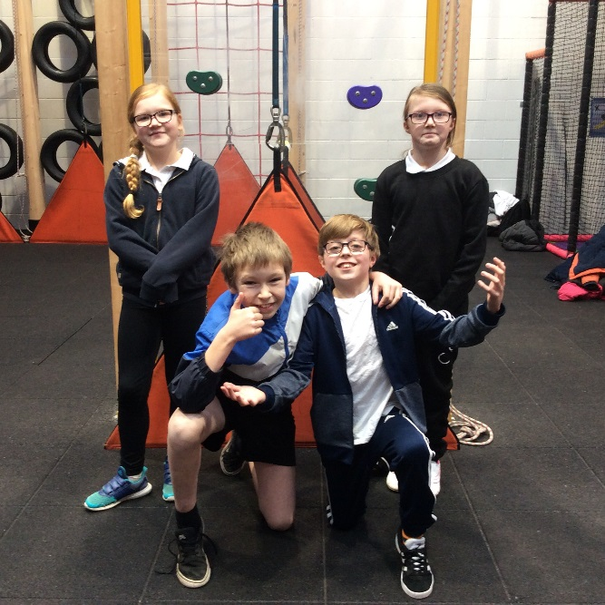
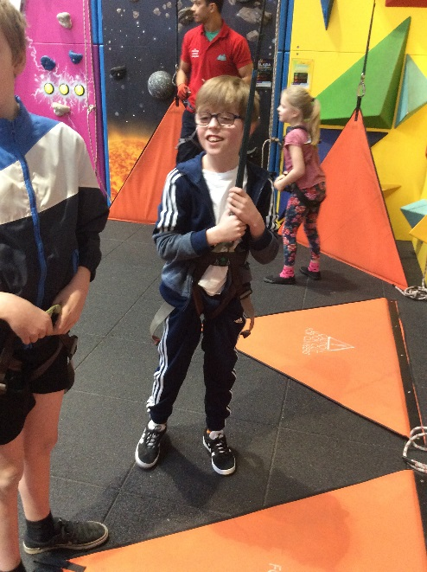
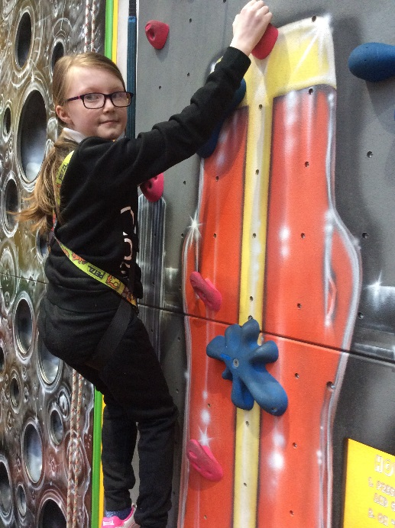
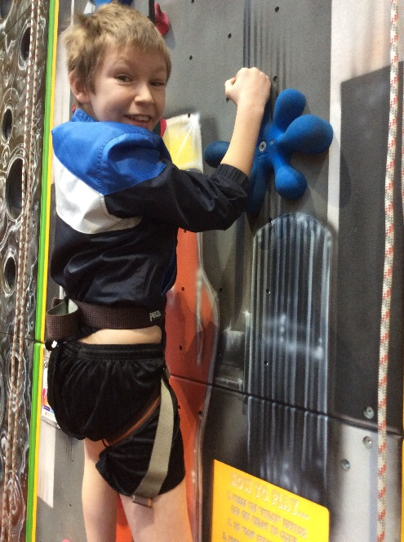
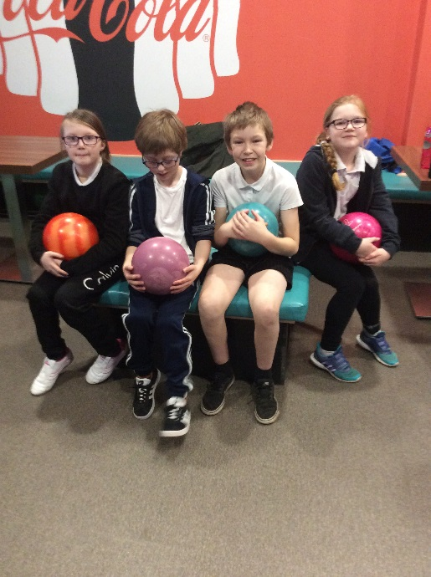

Mrs Rawes is leaving Cawood.

It is with much sadness that I announce that Mrs Rawes will be leaving us at the end of this term.

Mrs Rawes will be taking up the post of Headteacher at Cowick Primary School. I am thrilled and delighted that she has been successful in her appointment as headteacher, and very excited that she will now have the opportunity to lead and develop the school. At the same I am sad to think that Mrs Rawes will shortly be leaving us. She has been at Cawood as a senior leader for 10 years. She has worked closely with Mr. Smith for a number of years and has been very helpful and supportive on my arrival just over a year ago. She has played a significant role in the development of the school, helping to bring the school to its current successful position. Mrs Rawes is very passionate about education and has given so much of her own personal time to helping and supporting children in their learning. I don’t think I have ever heard a choir sing better than the choir at Christmas time, singing at the Old Boys school and at the Harrogate International Centre.

Year 5 also had a great time at Marrick Priory in December and there are many things that Mrs Rawes does, working behind the scenes and often on her days off, which has been very much
appreciated. Mrs Rawes has taught many children at Cawood and has great skills to take to her new school. We hope that she will also take with her all the fine qualities and values that we hold very dear to us at Cawood: a love for learning, hope, friendship, thankfulness, and that great care and consideration that we have for everyone in our community. We all wish Mrs Rawes every success at Cowick and I’m sure that she will keep in touch with us.

Next term, in April, Mrs Tomsett will be teaching the class an extra day which means that she will be teaching three days a week which is wonderful, as it will give a lot of stability and continuity for the children. We will be looking to appoint a teacher on a temporary basis to cover the other two days.

We are here to support your child and to provide the very best education that we can. Please do not hesitate to come and see us if you have any questions or concerns. We are very dedicated to the children and the school and we are always happy to help.

8th May 2018 Curry and quiz night.
Plenty of time to get a team together and to come along
and enjoy this social event with friends. Last year the curry
was great and enjoyed with the odd glass of wine.

Summer fair
7th July 2018
Let’s make it another great event!

14/3/18 – Next meeting at 7pm

Y6 Residential to
Dobroyd Castle
Robin Wood
(September 19th – 21st )
Parents and carers meeting on
Wednesday 28.2.18

A great afternoon at Read School.

Year 5 children had a fabulous time at the
Read school last week. It is always an amazing
experience watching a musical and the
production was excellent. The children were
very well behaved and it was a joy to go to this
event. It was also wonderful to see some of our
ex- pupils on stage and doing really well. They
were brilliant!

A great afternoon at Read School.

Year 5 children had a fabulous time at the Read school last week. It is always an amazing experience watching musical and the production was excellent. The children
were very well behaved and it was a joy to go to this event. It was also wonderful to see some of our ex pupils on stage and doing really well. They were brilliant!

Healthy pack ups please.
Please remember to keep the lunch time pack-ups healthy.
Please do not include any sweets in the pack up, including bars of
chocolate or chocolate orange etc.
Part of our drive to be a happy and healthy school.

Collective Worship

If you would like to join us you would be very welcome. There will be chairs out for you in the hall and the worship starts by 9.10am and it is usually finished by 9.30am. We vary the day of the class worship to give maximum chance for parents to attend over the year, especially if parents work on certain days. The dates for this term are on a Thursday and are:

Date | Class name | Teacher
1.3.18 | Class 4 | Mrs Rawes
8.3.18 | Class 5 | Mrs Walker
15.3.18 | Class 3 | Mrs McKee
22.3.18 | Class 1 | Mrs Mudge

Our worship also picks out references to our Christian values of hope, friendship and thankfulness which underpin the life and ethos of the school.

Bikeability 19.2.18 The first day back after the half
term break.
This is for year 6. Remember to bring your bike and
helmet into school. There is a theory session and a bike
check. Don’t be caught out as this is the first Monday after the
break.

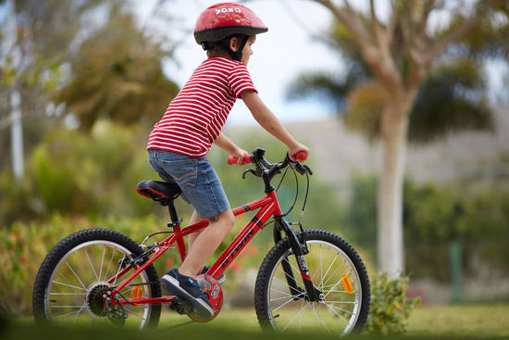

Thank you for your continued support. I hope you have a good week.

Nick Payling

Headteacher

Holidays and Training Days 2017 – 2018

 | School closes | School re-opens | Training Days
Spring half-term | Fri 09 Feb 2018 | Mon 19 Feb 2018
Easter | Thur 29 Mar 2018 | Tue 17 Apr 2018 | Mon 16 Apr 2018
May Day | Mon 7 May 2018
Summer Half-term | Fri 25 May 2018 | Tues 5th Jun 2018 | Mon. 4th June 2018
Summer | Fri 20 Jul 2018

Please note that
the last day of
the Spring term
is Thursday
29.3.18

Midday supervisor vacancy

There is a vacancy for a midday supervisor. Please let the office know if you are able to come in and support us in taking on this important role in school. We really need someone to come in and supervise the children on a Thursday and Friday lunchtime for roughly an hour a day. This is also a good way to get to know more about the school and would be great experience for anyone interested in working in school or with children in the future.

Telephone: 01757 268368

___________________________________________________________________________

Parent Helpers 2017 – 2018

I can help with: Please tick | Regularly | Occasionally
Classroom activities
Educational visits
Reading with children
Activities at home e.g. preparation of resources /collating vouchers, etc

Signed: _____________________________

Parent/Carer of: ____________________________________
Message from Home/School Liason Officer

Dear parents and carers,

I am well known at school as a governor and teaching member of staff with a specialism for helping and supporting all children in school across the age ranges. From January I am starting a new role in school as the home school link worker. I am very dedicated to helping all children in school, and particularly supporting children who may have anxieties, worries or may be displaying signs of developing an issue which can arise from a variety of situations faced both at home and school. My role is to offer support and work through matters with children, staff and parents. I feel that this is an essential role in school as I can, if needed, provide a link between school and the home for parents or carers with general school welfare matters.

I will be running sessions throughout the week for parents, carers and children. These sessions are an opportunity for you to come and talk things over. If your child is experiencing anything at home that may be impacting on school life, or you have any concerns regarding the wellbeing of your child in the school environment I would invite you to come and see me.

Sessions can work on a casual ‘drop in’ one to one basis, but I will be available from 8.15am if you wish to make an appointment to see me. Alternatively, I will be available at the start and the end of the school day if you wish to catch me for a quick chat and make an appointment for a longer meeting.

We are here to provide the very best education we can for the children. Please do not hesitate to contact me with any concerns you or your child may have.

I am available at:

- Monday – Friday
- 8.15am by phone
- 8.30am - 8.45am for a meeting
- 3.15pm – 3.30pm for a meeting

I look forward to meeting you.

Kind Regards

Hazel Coleman
Home School Liason Officer.

AFTER SCHOOL AND LUNCHTIME CLUBS – Spring (February) 2018

Name ……………………………………………. Class …………………………….

Day | Club | Key stage and class | cost | Max.  Number | Start date
Monday  lunchtime | GARDENING CLUB  Mrs Sykes and Mrs Kershaw | YR1, YR2, YR3 | Free | - | Monday  26/2/18
Monday  after school | ART Key Stage 1  Mrs Hodgson | Class 1 & 2 | Free | 8 | Monday  26/2/18
Monday  after school | Netball  Mrs Hornsby | KS2 | Free | 15 | Monday  26/2/18
Tuesday  lunchtime | Choir Key stage 2  Mrs Rawes | KS 1 and KS 2  (New and existing members) | Free | 30 | Tuesday  27/2/18
Wednesday  lunch time | Strings (string ensemble)  Mr. Payling | KS 1 and KS 2 | Free | 5 | Wednesday  28/2/18
Wednesday  after school | Full orchestra  NYCC Music Service | KS 2  For musicians  learning an  instrument. | £10 for 5 weeks | 5 | Wednesday  21/2/18
Wednesday  after school | Fun - KS 1  Multi – sports and fitness.  Club Doncaster | KS 1 | £10 for 5 weeks | 16 | Wednesday  21/2/18
Wednesday  after school | Key stage 2 football | KS 2 | £10 for 5 weeks | 16 | Wednesday  21/2/18
Thursday  after school | Fun– KS2  Multi – sports and fitness.  Club Doncaster | KS 2 | £10 for 5 weeks | 16 | Thursday  22/2/18
Thursday  after school | Key stage 1 football | KS 1 | £10 for 5 weeks | 16 | Thursday  22/2/18
Thursday  after school | Recorders with Mrs Walker | KS 2 | free | 16 | Thursday  22/2/18

Name ……………………………………………. Class …………………………….

Please indicate which clubs you are interested in.

I agree to my child participating in the activities described. For after school clubs:

My child will walk home My child will be collected
(Please tick) (Please tick)
Signed ………………………………………………..

If you are able to help with transport to and from selected sporting events this term, please complete the form and return to the school office. On return of the completed form, you will be asked to complete a Validation of Voluntary Vehicle use. A copy of your current vehicle insurance documents and driving license will be made. We thank you for your ongoing support.

I am able to help with transport

Parent/Carer name ______________________________

Signature ______________________________________

DATES 2017/18
Date | Event
2nd Feb | 1pm – 3pm Ten pin/rock climbing Selby Leisure Centre. – selected pupils.
8th Feb | Class 2 Worship
Half term holiday February 12th - 16th

Monday 19th Feb | School opens for the children (Y6 remember your bikes and helmets)
21st Feb | PM Mini tennis festival at Brayton High School Year 5 and 6 selected pupils.
26th Feb | Bikeability – Year 6
27th Feb | Bikeability –Year 6
28th Feb. | Residential meeting for Y6 parents and carers (6pm – 6.30pm)
1st March | World Book Day
8th March | 1.15pm – 3pm Gifted and talented sports at Brotherton and Byram- selected pupils.
16th March | Able writer’s day – Selected pupils from Y3 and Y4.
19th March | Yorkshire Schools Fairtrade conference – Afternoon.
17th – 23rd March | Sports relief – activities TBC
26th March | Decorate an egg competition starts this week.
27th March | 1.30pm – 3pm High 5 Netball at Selby High School Yr group and selected pupils TBC
27th March | Parent’s evening
28th March | Parent’s evening
Thursday 29th March | 2pm Easter celebration service at All Saints Church TBC
Thursday 29th March | Last day of the Spring term
Easter holiday March 30th – April 13th

Monday 16th April | Training Day 4
17th April | School opens for the children
25th April | 9.30am Kwick Cricket at Selby Cricket Club – selected pupils
7th May | Spring Bank holiday
14th May – 17th May | Key stage 2 Sats week
21st May – 26th May | RE week
28th May to 1st June Half term holiday

Monday 4th June | Training day 5
5th June | School opens for the children
11th June – 15th June | Phonics week
13th June | 6.30pm New starters meeting TBC
19th June | Class photographs TBC
21st June | 1.15pm – 3pm Tri Golf- Brotherton and Byram – Y3 and Y4 selected pupils.
27th June | 1.10pm Sports Day
5th July | 1pm - 2.30pm New starters welcomed
6th July | 1.30pm Change for Life multi skills festival at Selby High Y1 and Y2 children –selected.
6th July | End of year reports to parents and carers.
7th July | Summer fair – Parents and Friends.
10th July | 9.30am Key stage 2 performance for parents and carers
11th July | 6.30pm Key stage 2 performance for parents and carers
17th July | Class swaps - transition
Friday 20th July | 9.15am Leavers assembly
Friday 20th July | Last day of the Summer term

